DATA SCIENCE CAPSTONE PROJECT REPORT
Wine Quality Analysis Using Python
Prepared by: Chidananda M

Executive Summary
This project demonstrates an end-to-end data science workflow using the UCI Wine Quality dataset. The analysis includes public data acquisition, data quality checks, exploratory data analysis, Random Forest regression, and K-Means clustering. In the uploaded test results, Random Forest achieves MAE 0.510, RMSE 0.664, and R² 0.413, outperforming the mean-prediction baseline. Clustering achieves its best tested silhouette score at k=2 (0.270), suggesting modest rather than strong separation. These findings are exploratory and should not be interpreted as causal evidence.

1. Problem Statement and Objectives
Wine sensory quality is subjective and can be costly to assess. This project investigates whether measurable physicochemical properties can help predict the sensory quality score and whether samples can be grouped by their measured properties. The aim is to provide analytical decision support, not to replace expert sensory assessment.
- Acquire a public dataset and document its source.
- Inspect data quality and document cleaning decisions.
- Explore distributions and relationships through summary statistics and visualizations.
- Train a supervised regression model and compare it with a simple baseline.
- Use clustering to describe groups of wines without using the quality label to form the clusters.
- Evaluate results critically and identify limitations and future work.

2. Methodological Approach
The pipeline comprises data acquisition, inspection, cleaning, exploratory analysis, an 80/20 train/test split, baseline and Random Forest regression, held-out evaluation, and K-Means clustering. A fixed random seed is used for reproducibility. Preprocessing for regression is placed in a scikit-learn pipeline so imputation is fitted on training data rather than the full dataset.

3. Data Collection
Dataset: UCI Machine Learning Repository, Wine Quality. Source: https://archive.ics.uci.edu/dataset/186/wine+quality. The dataset contains red and white wine samples with physicochemical attributes such as acidity, residual sugar, chlorides, sulfur dioxide, density, pH, sulphates, and alcohol. The target is the sensory quality score. The notebook adds a wine_type field based on the source file.
The notebook attempts to download the official ZIP archive and includes a local CSV fallback if internet access is unavailable. For final submission, record the exact raw and cleaned row counts from the executed notebook.

4. Data Cleaning and Preprocessing
The notebook checks shape, data types, summary statistics, missing values, duplicate rows, and negative numeric values. Exact duplicate rows are removed; the target is coerced to numeric and records without a target are removed. Wine type is converted to a categorical variable and one-hot encoded for regression. Median imputation is included in the model pipeline. The number of removed duplicates and final sample size should be documented from the notebook output.
Cleaning caveat: removing exact duplicates is a reasonable initial choice, but duplicate records could in some contexts represent legitimate repeated observations. The effect of this decision should be acknowledged.

5. Exploratory Data Analysis
The notebook examines the quality-score distribution by wine type, alcohol distributions by wine type, numeric correlations, and group-level means. These plots should be used to discuss target imbalance, differences between red and white samples, potential outliers, and relationships between measurements. Correlation indicates association and does not demonstrate causality.
Before submission, add two or three specific observations from the notebook's EDA charts. Avoid claiming a relationship unless it is visible in the plots or supported by the calculated summaries.

6. Supervised Modeling and Evaluation
The target is the numeric quality score. A DummyRegressor that predicts the training-set mean provides the baseline, and a RandomForestRegressor with 300 trees provides the main model. The test partition is used for final evaluation.
Model | MAE | RMSE | R²
Random Forest | 0.510 | 0.664 | 0.413
Mean baseline | 0.694 | 0.868 | -0.001
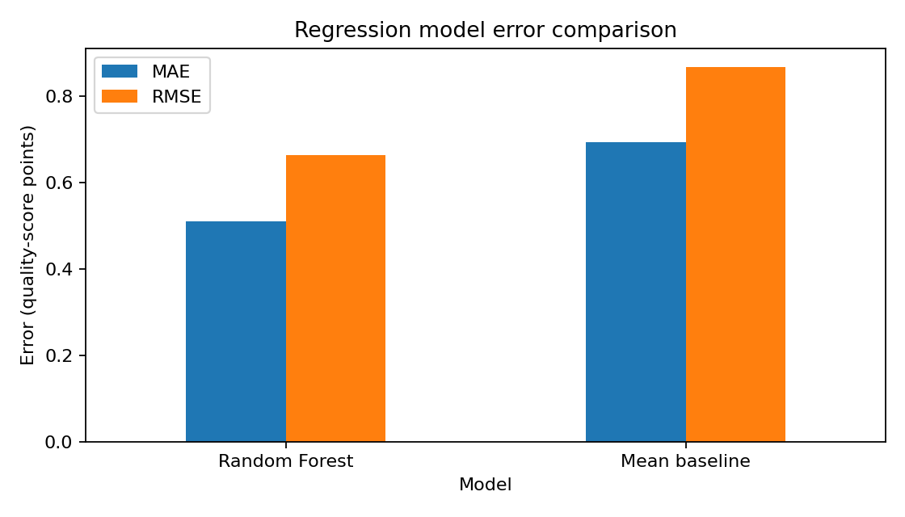
Interpretation: Random Forest has MAE 0.510, meaning predictions differ from actual scores by about half a quality-score point on average in this test split. RMSE is 0.664 and is larger than MAE, which is consistent with some larger prediction errors. R² is 0.413, so the model captures some but not all variation. Compared with the mean baseline, all reported metrics improve. Performance is moderate rather than sufficient to treat the predictions as authoritative quality assessments.

7. Feature Importance
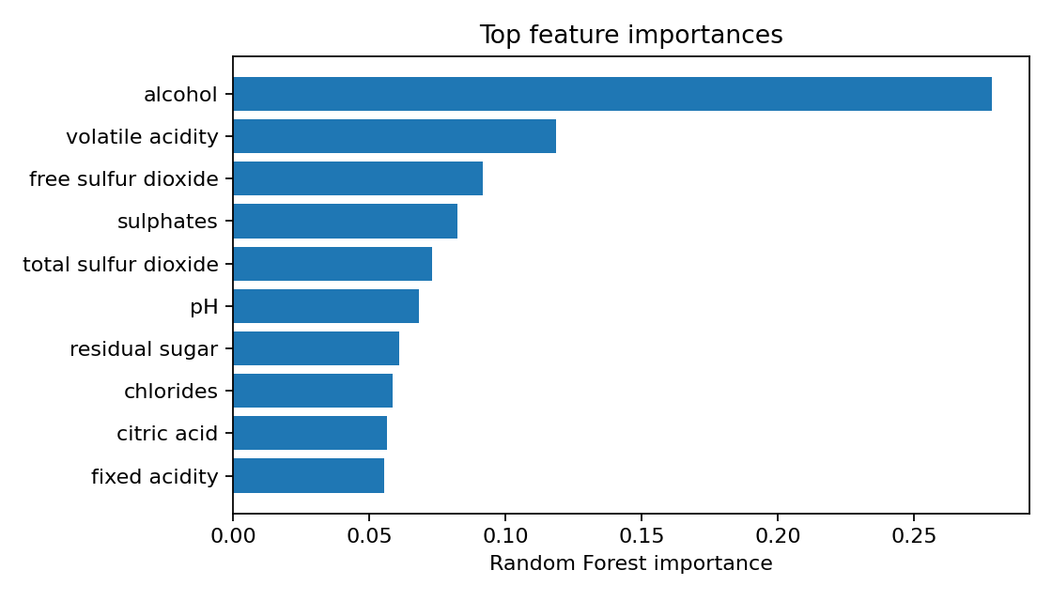
Top features by the supplied Random Forest importance output:
- alcohol: 0.279
- volatile acidity: 0.119
- free sulfur dioxide: 0.092
- sulphates: 0.082
- total sulfur dioxide: 0.073
Alcohol has the highest reported importance (approximately 0.279), followed by volatile acidity (approximately 0.119), free sulfur dioxide (0.092), sulphates (0.082), and total sulfur dioxide (0.073). These are model-based importance scores, not causal effects. Correlated features can share or distort importance.

8. Unsupervised Modeling: K-Means
K-Means is applied to standardized numeric physicochemical features, excluding the quality target. Silhouette scores for k values from 2 to 7 are compared.
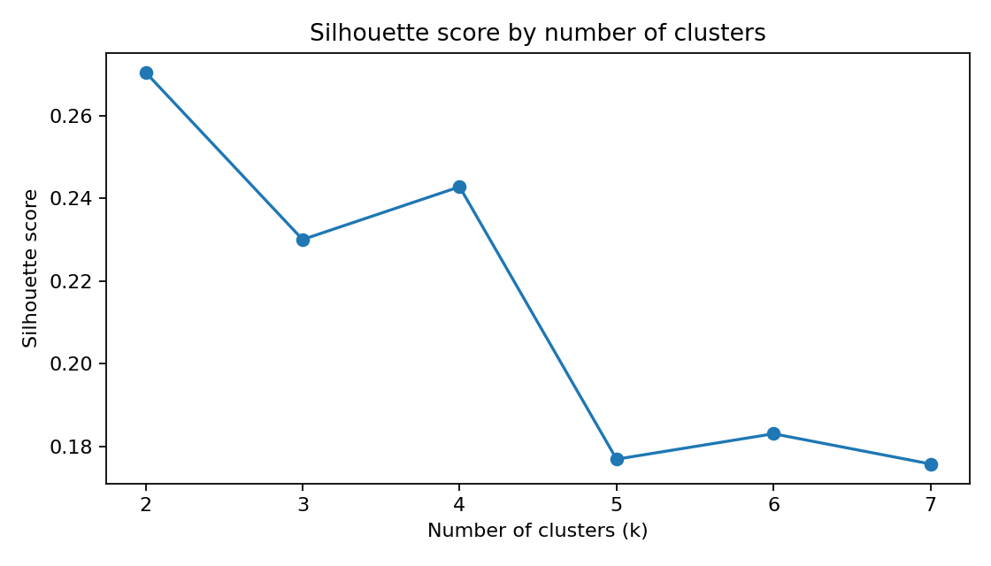
Among tested values, k=2 has the highest silhouette score (0.270). A score of this size suggests modest cluster separation; it does not prove that the groups are natural or commercially meaningful.
cluster | size | mean_quality | mean_alcohol | mean_volatile_acidity | mean_density
0.000 | 3918.000 | 5.872 | 10.600 | 0.276 | 0.994
1.000 | 1402.000 | 5.581 | 10.406 | 0.534 | 0.997
In the supplied cluster profiles, Cluster 0 contains 3,918 samples with mean quality 5.872, mean alcohol 10.600, mean volatile acidity 0.276, and mean density 0.994. Cluster 1 contains 1,402 samples with mean quality 5.581, mean alcohol 10.406, mean volatile acidity 0.534, and mean density 0.997. These differences are descriptive; they do not imply cluster membership causes a quality outcome.

9. Optional Classification Extension
The notebook also includes an optional binary classification task where quality ≥ 7 is treated as the higher-quality class. If included in the final submission, discuss why the threshold was selected and report precision, recall, F1-score, confusion matrix, and class balance. Accuracy alone can be misleading if the classes are imbalanced.

10. Insights and Recommendations
- Use Random Forest as an exploratory predictor rather than a definitive quality judge; test-set R² is 0.413.
- Investigate alcohol and volatile acidity further because they have the highest feature-importance scores in this fitted model.
- Use cluster profiles to formulate hypotheses, then validate them on additional samples and domain knowledge.
- Tune model parameters with cross-validation on training data only and compare against gradient boosting or ordinal models.
- Evaluate generalization on an external dataset, ideally from different producers, regions, or vintages.
- Consider permutation importance or SHAP for interpretation, while documenting the limitations of each method.

11. Challenges, Successes, and Reflection
The pipeline integrates multiple stages and compares machine learning with a transparent baseline. Potential challenges include duplicate handling, network-dependent data acquisition, a bounded and subjective target, correlated predictors, and interpreting cluster quality. For an authentic internship reflection, add a short first-person paragraph describing any execution issues encountered, how they were resolved, and what you learned. Do not claim to have faced a challenge unless it occurred during your work.

12. Limitations and Future Work
- Quality ratings are subjective and may not represent every consumer's preferences.
- A single random train/test split gives only one estimate of generalization.
- Feature importance is not causal evidence and may be affected by correlated variables.
- K-Means depends on scaling and the chosen number of clusters; silhouette score alone is not enough to validate segments.
- Future work could include repeated cross-validation, hyperparameter tuning, calibration/uncertainty estimates, external validation, and contextual variables such as vintage or region if available.

13. Conclusion
On the supplied test results, Random Forest regression improves over the mean baseline and achieves R² 0.413, MAE 0.510, and RMSE 0.664. Alcohol and volatile acidity are the leading reported features by model importance. K-Means selects two clusters among the tested options, but the silhouette score of 0.270 indicates only modest separation. These results support further investigation, while external validation and stronger interpretation methods are needed before practical deployment.

References
Cortez, P., Cerdeira, A., Almeida, F., Matos, T., & Reis, J. (2009). Modeling wine preferences by data mining from physicochemical properties. Decision Support Systems, 47(4), 547–553.
UCI Machine Learning Repository. Wine Quality dataset. https://archive.ics.uci.edu/dataset/186/wine+quality
Scikit-learn documentation. https://scikit-learn.org/stable/

Appendix: Reproducibility
The accompanying Jupyter Notebook contains the executable analysis. Include the notebook and generated CSV outputs as supporting files if your instructor permits. Confirm the dataset download, review all plots, and fill in the raw/cleaned row counts and personal reflection before submission.

